Bash script using if statement:

**Program 1:**

#!/bin/bash

echo "Enter a number:"

read number

if [ $number -eq 0 ]; then

echo "The number is zero."

elif [ $number -gt 0 ]; then

echo "The number is positive."

else

echo "The number is negative."

fi

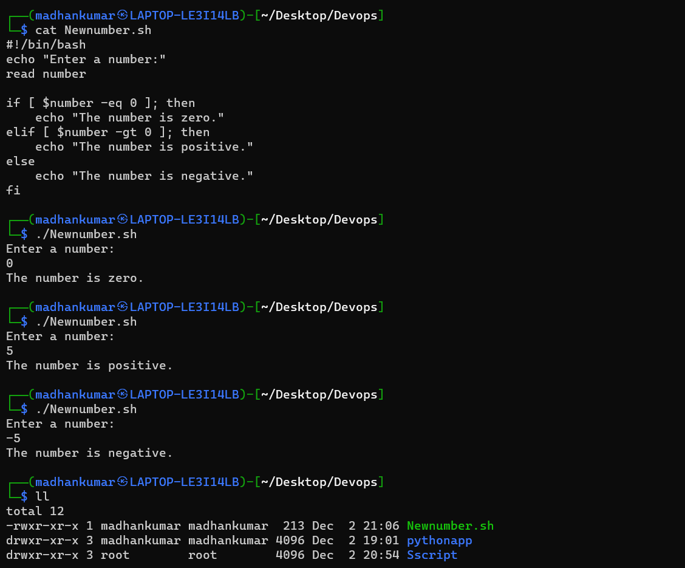

**Program 2:**

**#!/bin/bash**

**age=25**

**if [ $age -ge 18 ]; then**

**echo "You are an adult."**

**if [ $age -ge 21 ]; then**

**echo "You are eligible to drink in some regions."**

**fi**

**else**

**echo "You are underage."**

**fi**

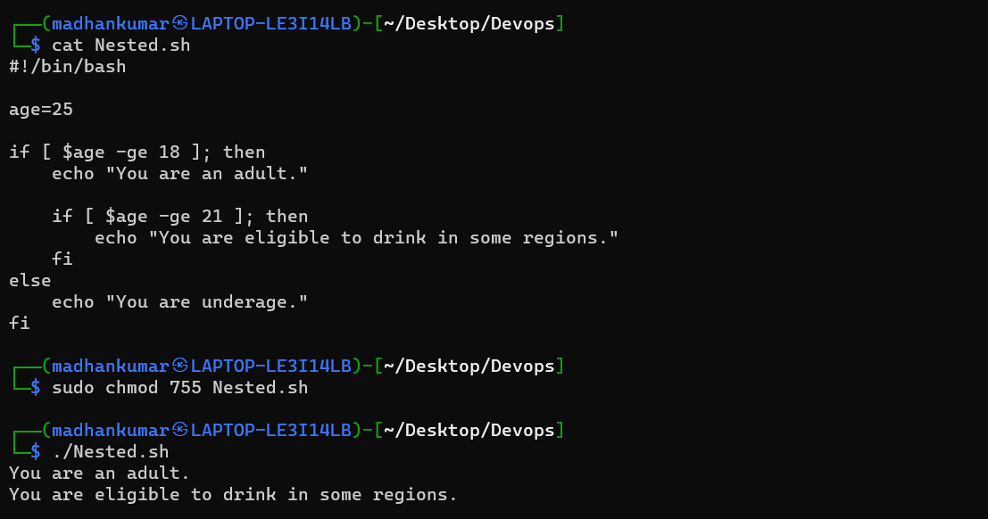

**Program 3:**

#!/bin/bash

echo "Enter your age:"

read age

if [ $age -eq 18 ]; then

echo "You are an adult."

if [ $age -ge 18 ]; then

echo "You are an adult and eligible to drink in some regions."

fi

else

echo "You are underage."

fi

